Yreka Jr Miners
Youth Football & Cheer
2021 season
Our objective is to encourage and increase youth participation in football, cheerleading and dance. We instill life-long values of teamwork, dedication, and a superior work ethic in the classroom and on the field. Our organization ensures a safe positive playing environment for all participants. By agreeing to sponsor a child you are helping to make the football/cheer program better. Your support allows us to provide the safest equipment and jerseys/uniforms for our players. We are not just playing football; we are molding responsible youth for life. Without your support this would not be possible!
I agree to sponsor _____________________________________ I would like to contribute $________________
___$50 ___$100 ___$150 ___$250 full sponsorship ___$other
Business Name _______________________________________

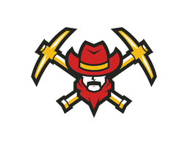
Please make Checks Payable to
Yreka Jr Miners
P.O. Box 812
Yreka, CA 96097
Thank you for your support!!We are a nonprofit and all contributions are tax deductible.
EIN#82-1518657

