Yreka Jr Miners
Youth Football & Cheer
2024 season
Our objective is to encourage and increase youth participation in football, cheerleading and dance. We instill life-long values of teamwork, dedication, and a superior work ethic in the classroom and on the field. Our organization ensures a safe positive playing environment for all participants. By agreeing to sponsor a child you are helping to make the football/cheer program better. Your support allows us to provide the safest equipment and jerseys/uniforms for our players. We are not just playing football; we are molding responsible youth for life. Without your support this would not be possible!
I agree to sponsor _____________________
I would like to contribute $________________
___$50 ___$100 ___$150 ___$250 full sponsorship ___$other
Business Name ______________________

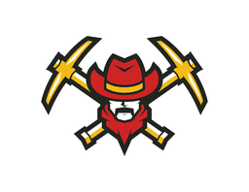
Please Make Check Payable to
Yreka Jr Miners
PO BOX 812
Yreka, Ca 96097

Your contribution is tax deductible we are a 501C Non-Profit EIN #82-1518657 Thank you for your Support!

