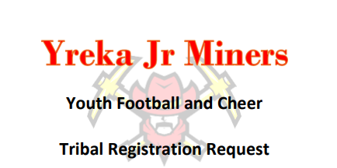

2024 Youth Football and Cheer Payment Request
Please take this form to your sponsoring tribe to request payment for participation. Your sponsoring tribal office will need to email this form back to us at yrekajrminers@gmail.com . Once we receive confirmation from tribe of payment verification, we will email you a Code to register with the approval amount.
$199 due 12/8/2023-2/28/2024 Veteran Registration
$250.00 due 3/1/2024-7/19/2024 Open Registration
Registered Player Name _______________________________________________
Parent/Guardian Name _______________________________________________
Phone Number ______________________________________________________
Parent Email ______________________________________________________
Tribe Contact Name and Phone_________________________________________
Amount of approved tribal contribution ___________ Date of Approval___________
Tribe Contact Players must be registered online at yrekajrminers.com.
Not Included required items:
Football cleats and socks
Cheer shoes, socks, spanks, leggings, and body liner are required items not included in the registration price.
Please make Checks Payable to
Yreka Jr Miners
P.O. Box 812 Yreka, CA 96097
Thank you for your support! We are a nonprofit and all contributions are tax deductible.
EIN#82-1518657

